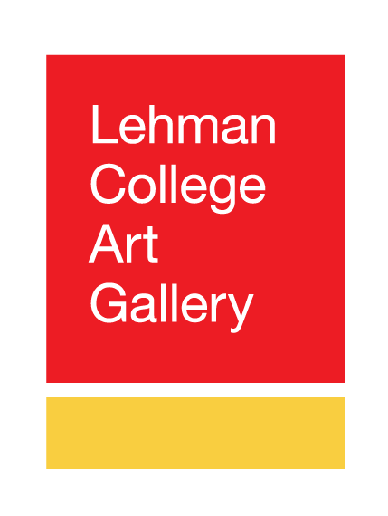Lehman Art Gallery, City University of New York
250 Bedford Park Boulevard West, Bronx, NY 10468 www.lehmangallery.org

Contact
Bartholomew F. Bland, Director, Lehman College Art Gallery at Lehman College
Bartholomew.bland@lehman.cuny.edu

FOR IMMEDIATE RELEASE – NEW EXHIBITION, SPRING 2026

The Painted Word: Text, Gesture, and Expression in Contemporary Art
February 11 - May 2, 2026
Reception: Wednesday, February 11, 5 - 8 pm

How do you paint a word? Words parade across pages and anchor bytes in a barrage of media. Words can be romantic – ‘I love you,’ or stand-ins for feelings that must out-‘I will miss you, ‘til we meet again’. The Painted Word, Lehman Art Gallery’s first exhibition in 2026, brings together three dozen contemporary artists who show us our powerful words and push the boundaries of written language through the physical act of painting.

At the heart of The Painted Word pulses the tension between form and meaning. Its artists transmute language, not always transparent, to show our inner feelings. They employ text not merely as a communicative vessel, but as a dynamic medium through which to excavate questions of identity, culture, emotion, and societal constructs. With bold, kinetic gesture and innovative typographic intervention, language is elevated from the confines of the page into painting's expansive realm, dissolving the boundaries between visual and linguistic expression.

The Painted Word delves into the intersection where gestural painting meets textual expression. Its artists seize upon language—traditionally perceived as a rational instrument of communication—and deconstruct it through intuitive, often deliberately chaotic gestural painting. In this transformation, they unleash the emotional and instinctual power that lies dormant within words. Rather than prioritizing legibility or narrative coherence, the works of the three dozen artists featured in The Painted Word foreground the subjective, fluid experience of language itself, inviting viewers to encounter the sensory and emotional dimensions of words as potent visual symbols.

The exhibition is accompanied by a comprehensive 125-page catalog featuring essays and entries by the curatorial team − Bartholomew Bland with Melissa Brown, Shawn Cheng, Sean McCarthy, and David Schwittek. Curatorial registration and research support is being provided by Ashley Lum and Maribelle Ceballos.

Artists: Chris Ashworth, Emma Beatrez, Mel Bochner, Kurt Boone, Scott Covert, Ben Durham, Nicky Enright, Shepard Fairey, Tony Fitzpatrick, Futura, Alicia Gibson, Jeffrey Gibson, Rachel Harrison, Evan Hecox, Meg Hitchcock, Rachel Lee Hovnanian, Royal “Kingbee”, Glenn Ligon, Jen Mazza, MRS, Loren Munk, John O’Connor, Rune Olsen, Lady Pink, Lee Quiñones, Maria D. Rapicavoli, Arlene Rush, Paula Scher, Miriam Shapiro, Sneha Shrestha, James Siena, Jaune Quick-to-See Smith, Despina Stokou, Nari Ward, Anna Warfield, and Peter Williams.

This exhibition is made possible through the generous support of our institutional partners, including the Sara Little Turnbull Foundation, Charina Foundation, Jarvis and Constance Doctorow Family Foundation, Edith and Herbert Lehman Foundation, Keith Haring Foundation, The Pierre and Tana Matisse Foundation, Milton and Sally Avery Arts Foundation, The New Yankee Stadium Community Benefits Fund, New York State Council on the Arts, the New York City Department of Cultural Affairs, and New York City Council Members Eric Dinowitz, Oswald Feliz, Kristy Marmorato, and Kevin C. Riley.

About Lehman College Art Gallery
Always free to the public, Lehman College Art Gallery has been serving the interests of our diverse audience from the Bronx and greater New York City since 1984. The gallery specializes in thematic group exhibitions that bring together famous artists with emerging talents. Education is an integral component of the Gallery’s programming and provides the basis of community outreach—from young students to senior citizens.

About CUNY
The City University of New York, CUNY, is the public university system of New York City. It is the largest urban university system in the United States, comprising 25 campuses: eleven senior colleges, seven community colleges, and seven professional institutions. The system includes more than a dozen art galleries and centers spread across its campuses.

